**Bridge**

**Neighbourhood Plan**

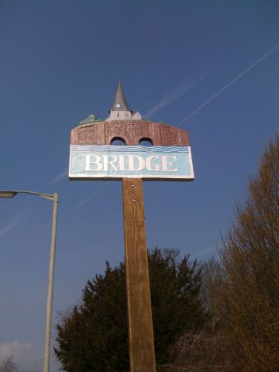

**Consultation Draft 6**

**August 2017**

**Contents**

Introduction …………………………………………………………………………………… 3

Our vision …………………………………………………………………………………… 3

Objectives …………………………………………………………………………………… 3

Map …………………………………………………………………………………… 4

Background …………………………………………………………………………………….4

Objective A. Building a Strong, Competitive Economy

& Ensuring the Vitality of the Village Centre ………………. 5

Objective B. Promoting Sustainable Transport …………………………………… 8

Objective C. To Deliver A Choice of High Quality Homes

With Good Design …………………………………. 11

Objective D. Promoting Healthy Communities …………………………………... 14

Objective E. Meeting the Challenges of Climate Change and Flooding …. 17

Objective F. Conserving and Enhancing the Natural Environment ……… 19

Objective G. Conserving and Enhancing the Historic Environment ……... 22

The Consultation Statement ……………………………………………………………... 24

Notes ……………………………………………………………………………………………….. 25

**Bridge Neighbourhood Plan**

Draft 6 –August 2017

### Introduction

This Plan sets out our vision for the future of Bridge until 2030 and lays down policies to help achieve that vision. This Plan has been drawn up under the provision of the Localism Act 2011.

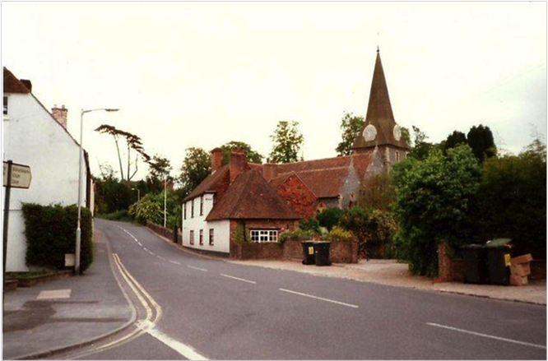

### Our vision

By 2030 Bridge will be a sustainable, identifiable village community that values its open space and separation from Canterbury. It will have developed local services and transport links that provide residents with a strong safe community identity. The historic fabric of the Village will be preserved.

### Objectives

The Neighbourhood Plan is constructed around seven objectives, which are:

1. to build a strong, competitive economy and ensure the vitality of the village centre;
2. to promote sustainable transport;
3. to deliver a choice of high quality homes with good design;
4. to promote a healthy community;
5. to meet the challenges of climate change and flooding;
6. to conserve and enhance the natural environment;
7. to conserve and enhance the historic environment.

### Map

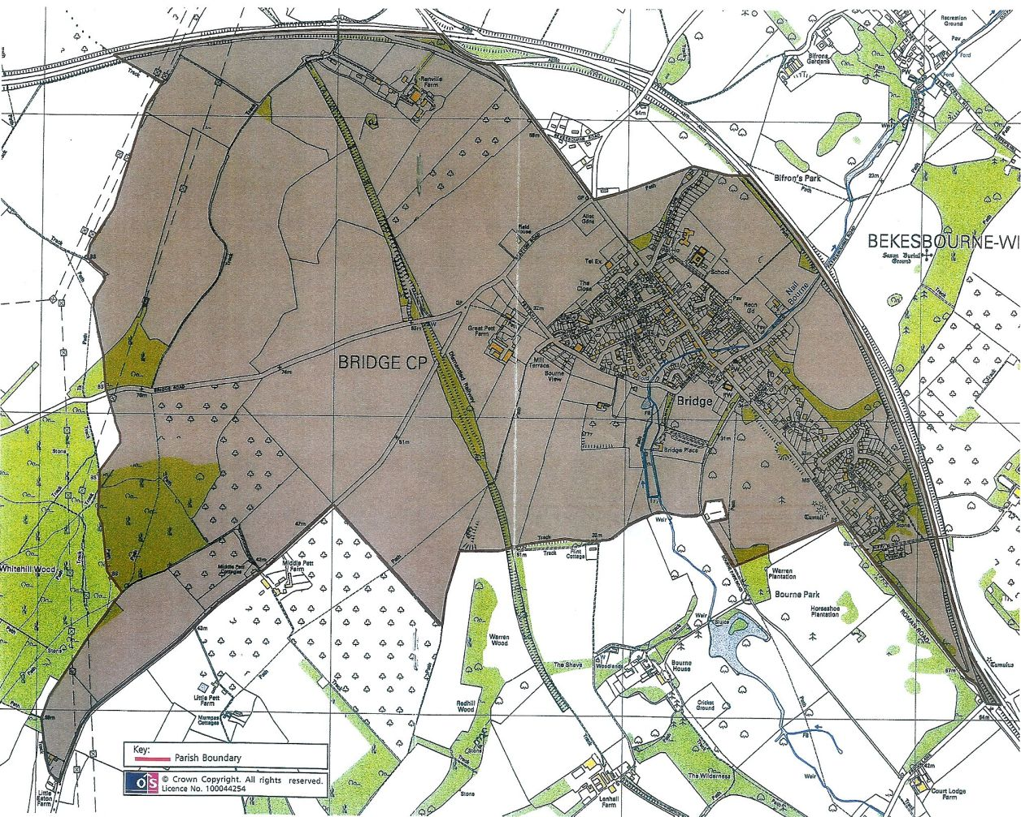

Area covered by the Bridge Neighbourhood Plan

### Background

The village of Bridge (51.2N 1.12E) lies in the Kent Downs Area of Outstanding Natural Beauty (AONB) and covers an area of 341 hectares (843 acres) to the south east of the City of Canterbury in the County of Kent. The village has a population of 1576 people (Census of 2011) living in 690 properties, of which 63 are listed buildings. The majority of the population (51%) is of working age and 55% are female. A significant number (39%) of people are qualified to NVQ level 4 (HNC) or above, which is rather greater than the average (30%) for the South-East of England.

### Objective A. Building a Strong, Competitive Economy & Ensuring the Vitality of the Village Centre

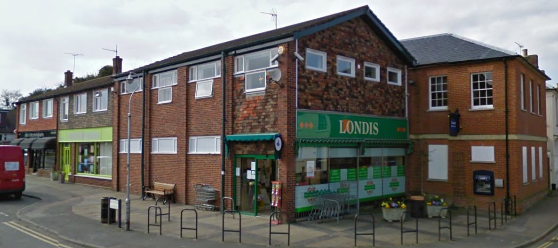

The village has a variety of business premises (*Appendix A)* but this Plan recognises that some may be unable to support economically viable employment for the full term of the Plan. The Plan will therefore endeavour to support any potential appropriate long-term employment opportunities. New small-scale business development in the village will be encouraged, wherever possible. A number of villagers already work from home and the Plan aims to encourage this by supporting measures that work towards good internet and communication networks in existing and any new development. Most wage earners work outside the village. Plans to increase the size of any Village Business Park are to be welcomed if they help to secure more work for local people*.*

**Policy A1**

The loss of business premises used for A1, A2, A3, A4 and A5 uses to other uses where this requires planning permission will not be permitted unless:

a) it can be demonstrated that the use of the premises for these purposes is no longer viable; or

b) the proposed alternative use would provide benefits for the local economy and community equal to or greater than the current use.

The National Planning Policy Framework (NPPF) states that ‘planning should operate to encourage and not act as an impediment to sustainable growth’.

**Policy A2**

Proposals for the development of new B1 business uses and Live-Work Units, within the built up area boundary of Bridge, will be permitted provided they:

i. do not lead to the loss of A1 shops or of community facilities;

ii. do not harm local residential amenity; and

iii. comply with other relevant policies in the Development Plan.

The NPPF states that the Plan should ‘facilitate flexible working practices such as integration of residential and commercial units’.

**Policy A3**

**To support the proposed conversion of redundant farm buildings at Great Pett Farm to units within use Class B1 appropriate to the rural setting, and within the current footprint, to provide local work opportunities, as long as this does not lead to increased road development and does not significantly increase traffic within the village.**

**Project A1**

To support residents with their plans to work from home by encouraging the spread of high speed internet access throughout the parish by maintaining and upgrading existing facilities when technology allows and by supporting the introduction of the most modern new communication systems within the Village.

CDLP 3.49 states that ‘there are also potentially quite significant benefits to be gained in relation to reducing traffic congestion, and hence improving air quality’ therefore home working should be supported.

**Project A2**

To support the presence of a Post Office within the Village.

### Objective B. Promoting Sustainable Transport

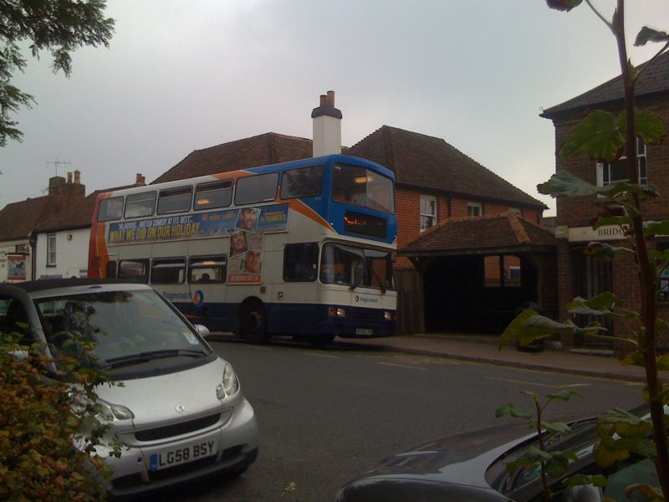

Bridge is well served by bus services to Canterbury, Dover and Folkestone. There are train connections from Canterbury to London and other destinations, including a high-speed link from Canterbury West to St Pancras. Bekesbourne railway station is approximately one mile from Bridge and provides an alternative to the journey by road to Canterbury, which has its own traffic congestion and parking difficulties. This line only serves the Canterbury East route.

The Canterbury District Local Plan has strategies relating to sustainable transport in the District and these form the Plan’s policies as far as they relate to Bridge.

Bridge currently lacks a safe cycle route to Canterbury. The Plan regards this as an essential development for the village. The Canterbury District Local Plan (CDLP) has provision for this development, which is strongly supported by this Neighbourhood Plan.

**Project B1**

To control the level and environmental impact of vehicular traffic and improve air quality, by:

* implementing a 20mph speed limit throughout the village
* installing air monitoring equipment
* encouraging driving instructors and delivery drivers to switch off engines while stationary

Parents collecting and dropping off children at school times create congestion in the village. Local parents will be encouraged to walk children to school individually or by 'Walking Bus' using drop off points away from the centre of the village. The Neighbourhood Plan will seek to make the environment safer for children by limiting and controlling vehicular access to the school at peak times. This would reduce congestion, alleviate car parking problems and improve air quality.

The introduction of electric charging points for cars in residential areas should be supported as technology allows.

**Project B2**

To promote the use of public transport and retain the existing bus service through Bridge.

Bridge has a good bus service, which is well used and valued by the community. Encouragement should be given to all residents to help the environment and reduce pollution by using the buses.

**Project B3**

To put pressure on Canterbury City Council to provide a safe cycle path between Bridge and Canterbury.

The current cycle route is along the busy A2050. A safe cycle route would enable children from Bridge to cycle to the secondary schools in South Canterbury. This would reduce car use on 'school runs' and provide health benefits.

**Policy B1**

Development proposals must integrate with and take opportunities to expand the local cycle route network especially the cycle routes shown on Map 12.

**Project B4**

To explore ways to alleviate parking difficulties.

Bridge has no car park. This is a problem especially pressing on weekdays in term time and a shortage of parking spaces drives people away from village shops and businesses. Employers should be encouraged to find their staff alternative parking away from the High Street. The potential for providing a village car park should be examined together with ways of increasing existing parking bays.

**Policy B2**

All development proposals will provide adequate provision for off street parking , in accordance with Kent County Council Highways parking standards, as set out in Interim Guidance Note 3: Residential Parking Standards or any update to this document. Development applications that would significantly increase parking problems in Bridge will be refused.

### Objective C. To Deliver A Choice of High Quality Homes With Good Design

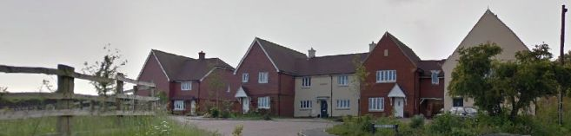

The Neighbourhood Plan will encourage the limited amount of housing required to meet local needs. The recent affordable homes project of eight units with ‘Local Connections’ criteria was over–subscribed. The village was divided on the need for more housing. In the March 2016 consultation, 21.7% of participants indicated a preference for no additional building anywhere in Bridge.

The Housing Needs survey carried out by ACRK in July 2017 identified a need for a small number of affordable housing units for local people.

The Parish Council has welcomed the completion of a Village Design Statement (VDS) which analyses the aesthetic makeup of the village and sets out the criteria, which should be applied to all new development.

**Policy C1**

All new development must be designed to a high quality which responds to the heritage, landscape and locally distinctive character of Bridge as described in the Village Design Statement. This will include careful consideration of :

a) the height, scale, spacing, density, layout, orientation, design and materials of buildings;

b) the scale, design and materials of the public realm (highways, footways, open space and landscape);

c) the need to conserve and enhance the fabric and setting of any heritage asset;

d) the need to conserve and enhance Conservation Areas and the Kent Downs AONB as set out in guidance in the Conservation Area Appraisals and Management Plans, and the Kent Downs AONB Management Plan and its associated Design Guidance ;

e) utilising sustainable building design, including energy efficiency and use of renewable energy;

f) incorporating the principles of ‘Secured by Design’ (SBD31) and, wherever possible, achieve SBD accreditation to ensure that a safe and sustainable community is maintained;

g) providing sufficient garden space for any existing and new dwellings in character with this rural area;

h) respecting the natural contours of the site; retaining existing important landscape features such as trees, hedges and ponds; and contributing towards landscape enhancement, including new open space where appropriate;

i) utilizing native species in new landscaping to conserve and enhance the natural beauty of the area and provide appropriate habitats for native fauna;

j) creating safe, accessible and well- connected environments that meet the needs of users;

k) avoiding unacceptable levels of light, noise, air or water pollution, and protecting the tranquillity and dark night skies of the area;

l) making best use of the site to accommodate development.

m) respecting the privacy, tranquility and setting of existing neighbouring properties.

New developments should encourage Bridge’s current community ambiance by strengthening neighbourliness through shared public spaces and access.

Any further new housing should consist of mixed scales and designs e.g. some 2-3 bed dwellings mixed in with 1 bedroom flats and some ground floor and single storey housing for the elderly.

Policy C2

Support further development for up to 8 affordable, rentable homes with ‘local connection’ restrictions. Affordable Housing must comply with the criteria and provisions in the existing Section 106 Agreement and should be held in trust to prevent sale on the open market.

Policy C3

Support limited housing development of up to 30 houses on a site yet to be agreed. Any development must comply with all the relevant policies set out in the Neighbourhood Plan.

Policy C4

Development proposals on brownfield sites will be permitted subject to the other relevant policies in the Development Plan. Development proposals on greenfield sites must demonstrate that the use of alternative brown field sites for the development has been fully explored and justify why the use of a greenfield site is necessary.

1. The Plan will not entertain any development which includes gardens which are not proportional to the size of the dwelling and will not give support to any development that does not adhere to this Policy. Recognizing the likely impact on the privacy and amenity of neighbouring properties, new developments must respect the separation between buildings and between buildings and the site boundaries.

The Plan will encourage energy saving and environmental benefits.

The Code for Sustainable Homes (CSH) was the national standard designed to improve the sustainability of new homes. Any replacement code will be endorsed by the Neighbourhood Plan.

The Planning Sub-Committee of the Parish Council will work to ensure that any proposed new housing is built to the highest environmental standard.

Planning decisions should utilise Sustainable Drainage Systems (SuDS) unless there are practical reasons for not doing so. It will not be acceptable for surface water run off to enter the foul water system.

Southern Water will improve reduction of ground water seepage into the sewage system.

Any new development must not place further pressure on the environment and compromise Water Framework Directive objectives.

In view of recent flooding in the village (2000/2001 and 2013/14) any new housing development must have adequate drainage and sewerage facilities incorporating appropriate property level flood resilience measures. It is important that surface water and draining facilities of any new housing development do not adversely affect those of existing housing and the general village environment.

**Policy C5**

No new development shall take place on any site unless a thorough, independent archaeological investigation of the site has been undertaken, and measures put in place to record and preserve any important archaeological features.

Bridge is part of a significant historical area and important finds and sites have been and are still being discovered. Some of these are of national importance. It is therefore imperative that before any development begins, an archaeological survey is carried out by an independent organisation.

### Objective D. Promoting Healthy Communities

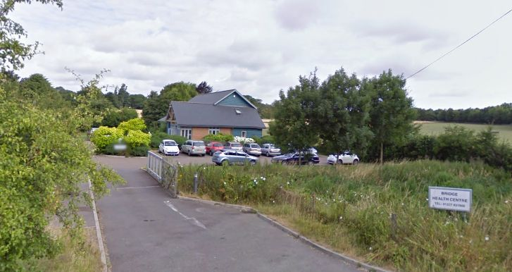

The Neighbourhood Plan will aim to protect the current high standard of living and low crime rate in Bridge. It will endeavour to ensure that sufficient leisure and community facilities are maintained to serve the village, and to promote new provision as the village develops. Facilities and groups that promote a sense of community and maintain these values will be supported and encouraged. The Neighbourhood Plan will protect existing green spaces within the village and encourage walking and enjoyment of the open spaces in and around the Village.

**Project D1**

To ensure that sufficient community and leisure facilities are maintained to serve the village.

Government guidelines state that ‘Access to high quality open spaces and opportunities for sport and recreation can make an important contribution to the health and well being of communities.’ The NPPF states that open spaces, sports and recreational buildings and land, including playing fields should generally not be built on unless and assessment has been undertaken which has clearly shown the open space, building or land to be surplus to requirements. The Neighbourhood Plan seeks to protect existing open spaces and recreational facilities within the village and on its outskirts. Open spaces such as the recreation ground and allotments and natural open space located both within and outside the village will be protected for the health and benefit of villagers and tourists alike.

Bridge is fortunate to have a strong community spirit, as reflected by the number and scope of groups and activities which take place within the village. These groups have strong co-ordinating bodies such as the Parish Council, the Parochial Church Council, sports clubs, school based activities and uniformed organisations as well as many interest groups (Appendix DX). Bridge has very few places in which groups can meet. The Neighbourhood Plan seeks to ensure that existing facilities are retained and where possible improved for the use of the community.

The Bridge Village Sports Pavilion will be retained for use within the recreation ground.

**Policy D1**

The loss of services and facilities of use to the community will not be permitted unless:

a) they are to be replaced with services and facilities of an equal or higher quality and value to the community on the same site or another equally suitable site within the parish; or

b) where the services and facilities can be demonstrated to be no longer needed or viable, any proposed alternative use would provide equal or greater benefits to the local economy and community, including through contributions to development on other sites.

**Project D2**

To work to change existing policies so that local children have priority in obtaining places at the local primary school.

The primary school is the hub of activity for the children in the community. It has expanded rapidly in recent years and now many of the pupils have little or no connection with the village. This policy would assist us in achieving our Environmental and Transport objectives by reducing commuting and congestion and encouraging walking and cycling. It would also promote a stronger feeling of community among our children and young people.

Bridge Health Centre is modern and purpose built in accessible premises on the edge of the village. It provides a wide range of GP services, therapies and treatments. Bridge is also fortunate to have a private dental practice. It is important that these facilities are maintained and supported as the village grows and more pressure is placed on services by development in South Canterbury.

The Neighbourhood Plan supports the deployment of a shared PCSO within the village and would welcome more involvement of a PCSO within the community. It seeks to strengthen links with the police. It supports the Neighbourhood Watch Scheme and would encourage its expansion. It also supports the Speedwatch Scheme, which is organised by the Parish Council with local volunteers and helps to make our village streets safer. It supports the introduction of a 20mph speed limit within the village.

**Project D3**

To work towards achieving a 20mph speed limit throughout the village.

**Policy D2**

Development proposals must retain and where appropriate enhance public rights of way and open green spaces around the village, as shown on Map X, which contribute to the health and well being of the residents.

Enjoyment of the countryside and preservation of its peace and quiet is important to the well-being of our rural community The Plan will maintain green spaces both within the Village and on its outskirts. Public footpaths will continue to be maintained, supported by the parish council and volunteers, as a supplement to the limited work of Kent Highways Authority. The enjoyment of green spaces and the effect that loss of access to it will have on the community will be a material factor to be considered should any proposal be put forward for whatever purpose which reduces the existing green spaces round the village. Any proposal which would reduce the potential for such enjoyment will be opposed. **See map Dx**

The Neighbourhood Plan envisages the retention of the Mill Centre and the use of it and other Village assets for the use of its youth groups which draw young people from the south of the District to participate in a range of sporting and cultural activities.

### Objective E. Meeting the Challenges of Climate Change and Flooding

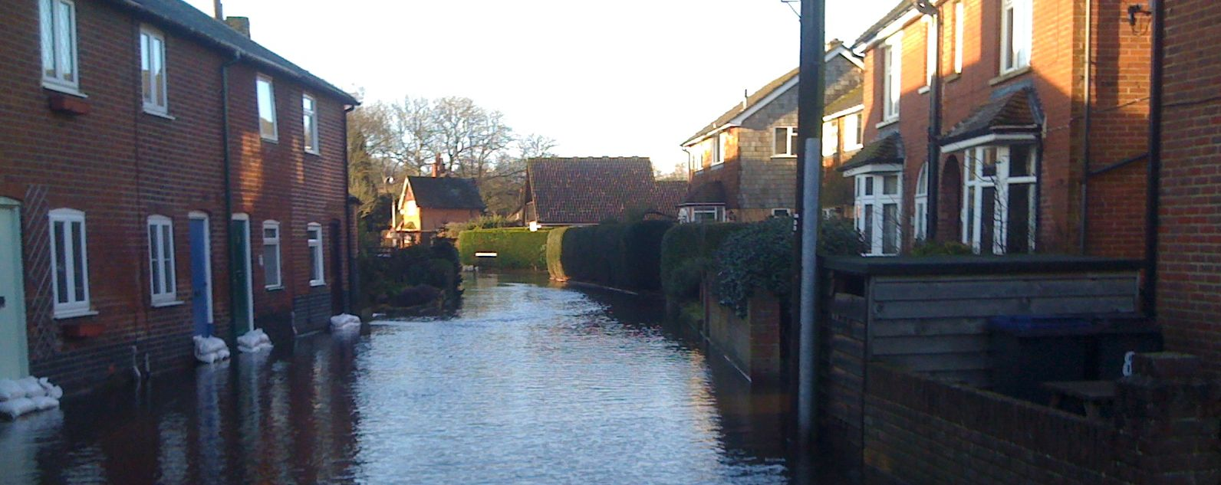

The Neighbourhood Plan supports the stance in Canterbury District Local Plan (CDLP) chapter 7. With reference to Bridge this indicates taking steps to minimise vulnerability and providing resilience with respect to the impact of climate change, and supporting the delivery of low carbon energy.

CDLP Policy CC3 on Combined Heat and Power calls for large developments to provide site-wide renewable or gas fired Combined Heat and Power (CHP) or connect to an existing CHP distribution network, but provides for exceptions based on viability.

The economic viability of such a scheme should not override the necessity for energy use reduction. Therefore this Neighbourhood Plan will strengthen the CDLP policy by reducing the terms of the exception.

##### Policy E1

##### The prevention of flooding

All development proposals need to be supported by surface water management strategy, which uses sustainable drainage system features to attenuate and restrict the rate and volume of surface water leaving the site. Surface water strategies should demonstrate that it will be feasible to balance surface water run-off to the greenfield run-off rate for all events up to the 1 in 100 year storm (including additional 30% climate change allowance) and set out how this will be achieved. Where sites are brownfield a strategy should always seek a betterment in the surface water runoff regime taking into consideration the Environment Agency document Groundwater Protection: Principles and Practice (GP3). Surface water strategies should also include details of a management and maintenance plan for the lifetime of the development.

Most of the built area of Bridge lies within the catchment area of the Nailbourne. As observed about the recent floods (see also CDLP 7.29-7.3.5), fluvial flooding, groundwater flooding and sewer overtopping are of particular concern to Bridge.

The Neighbourhood Plan supports the CDLP 7.34 in regard to Southern Water continuing to repair the sewer to secure against ingress and the prevention of any significant further development until the major improvements have been carried out (such as new culverted outfalls, major pumping at outlets or large attenuation lakes).

The Neighbourhood Plan Objective will tighten the CDLP Policy CC11 on Sustainable Drainage Systems by only permitting surface water drainage back into the ground. This will reduce the strain on the drains and the Nailbourne itself. The policy is also enhanced to include all planning decisions, not just those in the flood risk area, since the whole catchment area impacts upon the flood risk.

The risk identified is so great that no development will be permitted in Flood Zone 2 or Flood Zone 3 areas.

### Objective F. Conserving and Enhancing the Natural Environment

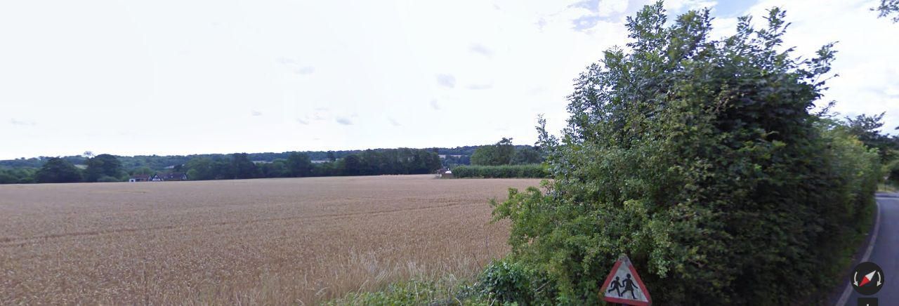

The National Planning Policy Framework states that the planning system should contribute to and enhance the natural and local environment.

The Bridge Neighbourhood Plan will seek to ensure that the existing natural environment is conserved, protected and enhanced. The Plan will protect existing green spaces in the village and on the outskirts to preserve and improve biodiversity where possible.

Canterbury District Local Plan (CDLP) (10.1) states “One of the City Council’s objectives is to protect and enhance the countryside, acknowledging its own intrinsic value, the diversity of landscapes, heritage and wildlife and recognising that a high quality environment contributes to the economic, social and cultural well-being of the district.”

CDLP (11.11) states “Open space performs a wide range of roles in enhancing the liveability of cities, towns and rural villages. Protecting open space for its amenity, ecological, educational, social and community benefits are now well established principles among planning authorities and other organisations”.

The Canterbury District Environmental Policy 2009 (Reviewed 2012) states “The protection and enhancement of open space is key to providing green space for wild life and people”.

The Planning Committee of the Parish Council will follow the policies of the Neighbourhood Plan and ensure that “garden grabbing” i.e. the use of gardens to develop as building plots does not take place in Bridge. Any new building should take place on brown field sites. The Parish Council Planning Committee will recommend the refusal of planning permission to pave over front gardens for car parking. Apart from aesthetic and environmental aspects this would help to prevent local flooding. The Plan will seek to maintain these open spaces.

The Draft Open Space Strategy for the Canterbury District 2014-2019 3.7 states that “…the design of public open space sets the scene for the housing, that it is considered at the start and throughout the design process, not as an afterthought and should provide an attractive setting as well as opportunities for leisure and recreation use”.

The Parish Council will work vigorously to ensure that provision for new green spaces is incorporated into any emerging development by scrutinising the planning applications and objecting to unsuitable plans.

**Project F1**

**To ensure that the development of South Canterbury is suitably contained to protect open space between the city and the village.**

**Policy F1**

Development proposals that reduce a sense of openness and separation between Bridge and Canterbury will not be permitted to ensure that the individual identity of these two settlements is retained.

CDLP (11.42) states “The objective of the green gap policy is to retain separate identities of existing settlements, by preventing their coalescence through development”.

The Neighbourhood Plan will continue to object to unwanted development in the Area of Outstanding Natural Beauty (AONB) on the south side of Canterbury to maintain the existing open space.

90% of respondents to the Neighbourhood Plan questionnaire opposed the merging of Bridge with South Canterbury, which would result in Bridge losing its identity as a thriving rural community

CDLP (11.44) states “The Council is concerned that this gradual coalescing between existing built up areas not only harms the character of the open countryside, but is having an adverse impact on the setting and special character of villages”.

The Neighbourhood Plan will encourage the conservation of the character of Bridge and the High Street in particular.

The Parish Council will seek to maintain open spaces which are of particular value for use in the community.

The NPPF (2012) (1.2) states that “Access to high quality open spaces and opportunities for sport and recreation can make an important contribution to the health and well-being of communities”.

NPPF (2012) (1.3) states “They help bring neighbourhoods together, and provide access, light, air and setting for neighbourhood buildings”.

The Parish Council will continue to encourage people of all ages to use and enjoy, volunteer to help with and maintain the recreation ground. The Council will encourage the education of local school children to participate in the Wild Flower Project on the recreation ground.

CDLP (11.14) states “It is important that allotments are retained where they can perform an important open space function and contribute to the City Council’s wider sustainable development objectives, including the production of local fresh produce and enhanced quality of life in terms of health, social activity…and wild life habitats”.

The Parish Council will actively encourage the take up and maintenance of the allotments in the village to provide local fresh produce and enhance the social wellbeing of the residents of Bridge.

Policy F2

Applications for additional external lighting within the Conservation Area will be refused if they would increase light pollution within the village and/or adversely affect their surroundings. The Neighbourhood Plan supports measures to reduce light pollution and promote the visibility and clarity of the night sky.

**Project F2**

**To support new developments that allocate land to uses such as sustainable farming, allotments and community orchards.**

The Plan will encourage and support the use of land to establish sustainable farming, allotments and community orchards to provide employment and enrich the well-being of local residents. A suitable area of land will be identified for a community orchard.

### Objective G. Conserving and Enhancing the Historic Environment

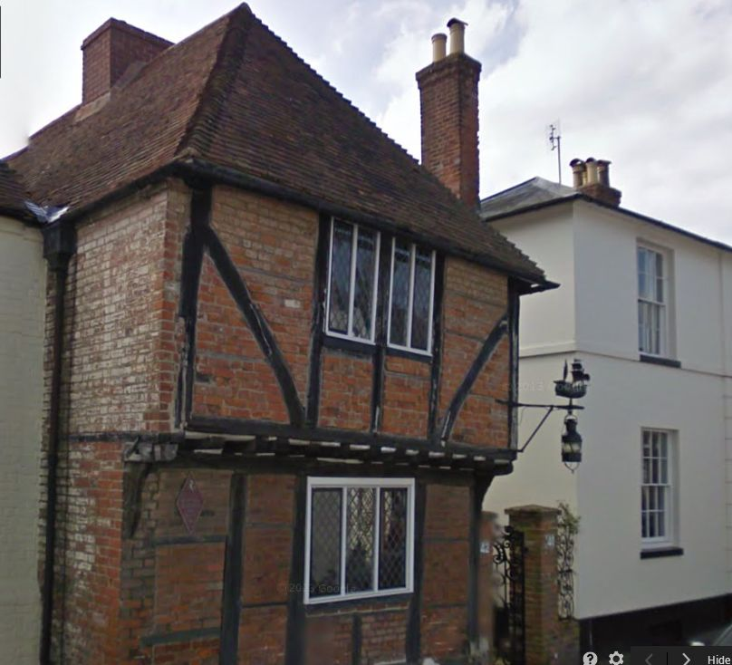

The village draws some of its character from the fact that it stands on the Roman road from Dover to London through Canterbury. This road became known as Watling Street. The bridge at Bridge is built over the Nailbourne, an intermittent stream which is often completely dry but is also capable of rising rapidly to flood low-lying areas in the village. The Nailbourne lies in a valley so that Watling Street rises up-hill in both directions from the centre of the village. Consistent with its age and location the village has more than sixty listed buildings dating from the early fifteenth century onwards.

**Policy G1**

To respect the existing village charm and character in terms of scale, style and setting of new developments as defined in the Village Design Statement.

The Plan will continue to ensure that any new development is appropriate to merge with the present building infrastructure.

CDLP Policy DBE1 states “All development should respond to the objectives of sustainable development and reflect the need to safeguard and improve the quality of life for residents, … minimise waste and protect and enhance the environment”.

“The City Council will therefore require development schemes to incorporate sustainable design and construction measures that must satisfy the criteria…”

The Parish Council Planning Committee will closely monitor the building materials intended for use in any proposed new building. While this applies to all buildings it is of particular significance to those intended for conservation areas in the village.

The CDLP Policy HE1 states that ‘Development must conserve and where appropriate enhance or reveal, the significance of heritage assets and their settings. Development will not be permitted where it is likely to cause harm to the significance of heritage assets or their settings.” The Neighbourhood Plan strongly supports this policy and the Parish Council will endeavour to maintain the distinctive historic character of Bridge.

### The Consultation Statement

In the final version, this section will contain a statement prepared to comply with the Neighbourhood Planning Regulations 2012. It will contains details of the persons and bodies were consulted about the proposed NP, explains how they were consulted, summarise the main issues and concerns raised by the persons consulted and describe how these issues and concerns have been addressed in the NP.

Who was consulted.

How people were consulted.

Main issues and concerns raised.

### Notes

Schedule 9 Part 1 of the Localism Act 2011 sets out the requirements for a Neighbourhood Development Plan in relation to the development and use of land in the whole or any part of a particular neighbourhood area specified in the plan.

The period of the Neighbourhood Plan (NP) is up to 2030 or 16 years.

The Neighbourhood Plan meets the basic conditions if –

1. having regard to national policies and advice contained in guidance issued by the Secretary of State, it is appropriate to make the NP,
2. the making of the NP contributes to the achievement of sustainable development,
3. the making of the NP is in general conformity with the strategic policies in the development plan for the area of the authority (Canterbury City Council?)
4. The making of the NP does not breach, and is otherwise compatible with, EU obligations, and
5. Prescribed conditions are met in relation to the NP and prescribed matters have been complied with in connection with the proposal for the NP.

Bridge Parish Council is a qualifying body and entitled to submit a NP for its own parish.

The Bridge NP expresses policies relating to the development and use of land within the neighbourhood area. It does not include any provision for excluded development such as national infrastructure. There is no other NP in place in this neighbourhood area.

**National Policies and Advice**

1. The National Planning Policy Framework (NPPF) refers to Neighbourhood Plans and seeks that those plans have regard to the policies in the NPPF and to be in ’general conformity’ with the Strategic Policies of the Local Plan.

1. The Bridge NP has regard to relevant policies within the NPPF.

### Appendix 1 List of organisations

Art in Bridge

Cribbage and Pot Boys Guild

Fish Scheme, which supports the elderly,

Nailbourne Horticultural Society,

Bridge And District History Society

Women's Institute

Hereon is notes and etc: work to do.

Reorganize the appendices, maps, etc.

A para about the Objectives, Policies and Proposals.

Pg8 w690 Policy A2 >> Appendix F >> Flood Risk Map.

Pg 11 w 1217>> Map12. Policy B1 >> Cycle Route on a local map??

Pg 12 w 1416 >>Appendix V>>Village Design Statement

Pg 12 w 1420 >> Appendix for results of March 2016 Consultation. (And others?)

Pg 13 w 1750 >> as above Pg12 1420 >> results of March consultation

Pg 18 w 2178 .Policy D4>> MapDx >>Green Spaces PROW etc

Pg 19 w 3154 >> Flood Map (to be Appendix F (see pg 8 ))

Pg 24 w 4449 >>Need a ‘proposals map’ (Combine with Map Dx?) Section F5

Pg 23 w4314 >> put all this into a map and a list of sites and a commentary? Appendix?

A Glossary

Appendix for the building classes, A1, A2, etc? that are mentioned early on?

Redo the page numbers and Contents page (do this point last)